MINUTES OF MEETING WITH SRI. DHARMENDRA PRADHAN, HONORABLE MINISTER IN SKILL DEVELOPMENT AND ENTREPRENEURSHIP & MINISTER IN PETROLEUM AND NATURAL GAS, GOVERNMENT OF INDIA IN INDIAN OIL GUEST HOUSE, FOREST PARK, BHUBANESWAR AT 8.30 P.M ON DT.15/11/2017.
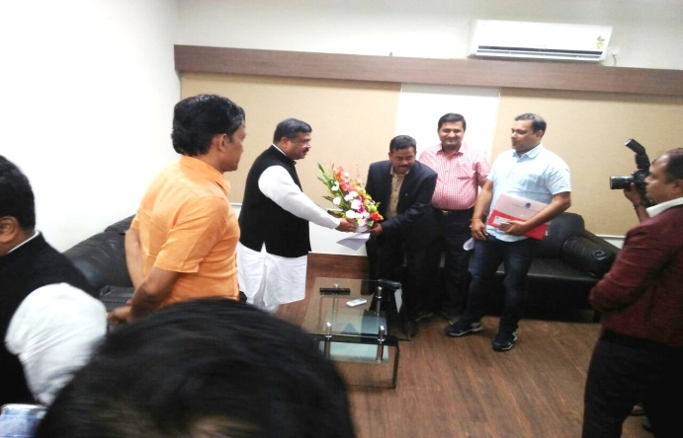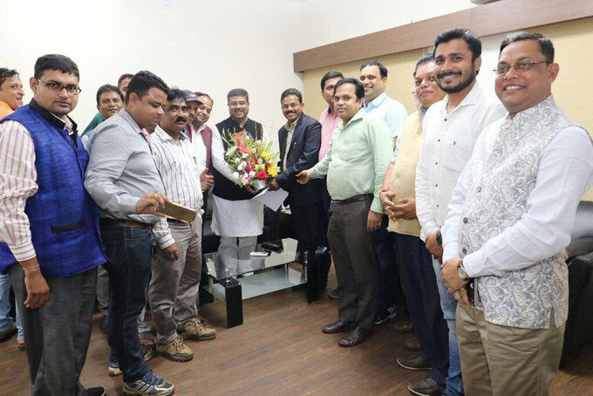
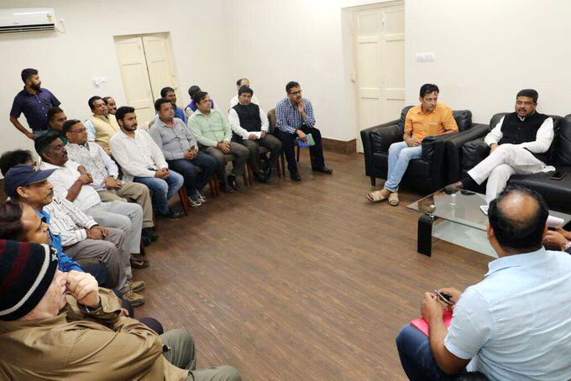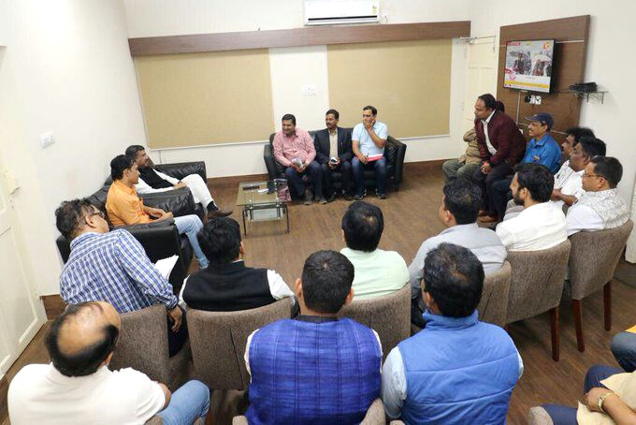
The SPITIA team made a discussion regarding the following points as per the Memorandum :
- Skill Training in Private ITI’s :
We requested the Honorable Minister to implement the Skill Training through our Private ITI’s for optimum utilization of the infrastructure, machineries and manpower. He assured us to implement various short term courses and new projects in Private ITI’s of our state with a vision of minimum 3 lakhs young mass to be trained every year, which will generate adequate revenue to the concerned ITI to sustain. He also expressed his views to make Odisha as a Model State in India in Skill Development Training Programmes.
- Overseas Training Programme for Trainees as well as Entrepreneurs:
In the action plan of Government of India through Skill India campaign to send 3 Lakhs Students to Japan for quality training, we requested to send at least 100 Private ITI students from our state to Japan initially for quality training along with the ITI Entrepreneurs to different countries to upgrade the Training process. The Hon’ble Minister suggested to train the ITI passed out trainees to make them learn Japanese Language after only he will take necessary steps to send them to Japan for Quality Training.

- Implementation of DGT Normative Fee Structure:
The DGT have already published a normative fee structure to implement in all states however, we requested a Gazette notice for the above Fee Structure should be published so that, the poor students can get the re-imbursement of their course fee like Diploma, Nursing, & other professional courses and also they will be eligible to get study loan under PMKRY scheme. The Hon’ble Minister assured us to take immediate steps for implementation of DGT Normative Fee Structure in our state.
- Central Placement Cell:
The State Govt. have formed the placement cell but they have shown the step motherly attitude by not including the Private ITI passed out Trainees. We requested him, to include the Private ITI Trainees in Central Placement Cell. He discussed regarding this point, but as this is controlled by state government, he advised to meet the state govt. officials to solve this issue.
- Financial Assistance for Quality Up-Gradation:
We requested Hon’ble Minister to include the Private ITI’s to be funded through CGTMSE (Credit Guarantee Fund Trust for Micro & Small Enterprises), PMKRY (Pradhan Mantri Kaushal Rin Yojana) and if possible World Bank Assistance. He assured to fund the Private ITI’s of our state through NSDC for development of Skill Centers and up-gradation of ITI.
- Wave out of Online Examination & Semester Pattern:
The Students coming from grass root level for ITI’s are not aware about the systems of Online Examination as it is not implemented in any other professional & technical course. So, we requested Hon’ble Minister to wave out the Online Examination pattern as well as the Semester System and also we requested to make our own Examination Center to stop the harassment of trainees to travel many kilometers to appear the AITT Examinations.
He assured us to wave out the Online Examination System and committed to wave out the Semester Pattern System and introduce Yearly Pattern in AITT Examination System for the students from the admission session August-2018.
He also advised to make a brief presentation regarding the difficulties and reforms required in ITI Examination pattern and a team of SPITIA will meet him in future regarding to resolve the Examination Issues so that the trainees of our state should not face any kind of harassment in future. So we request all the members to mail us their suggestions regarding AITT Examination and Gradation to our SPITIA official mail Id: spitiaodisha2015@gmail.com.
- Other Points:
The SPITIA team discussed regarding +2 equivalency of ITI, reformation of new civil norms & requested the Hon’ble Minister to support and encourage the Private ITI Entrepreneurs of our state and not to de-affiliate any active ITI of our state and give reasonable time for up-gradation to quality infrastructure for quality training. Our president suggested to introduce local language question papers for our state for AITT Examination and hon’ble minister has given his consent to introduce question papers in all national and regional language. We also requested the hon’ble minister to simplify the Gradation Format.
Sd/-
Er. Debashis Acharya
General Secretary
SPITIA, Odisha.

